Build SOHO Network

1. Image of SOHO setup :

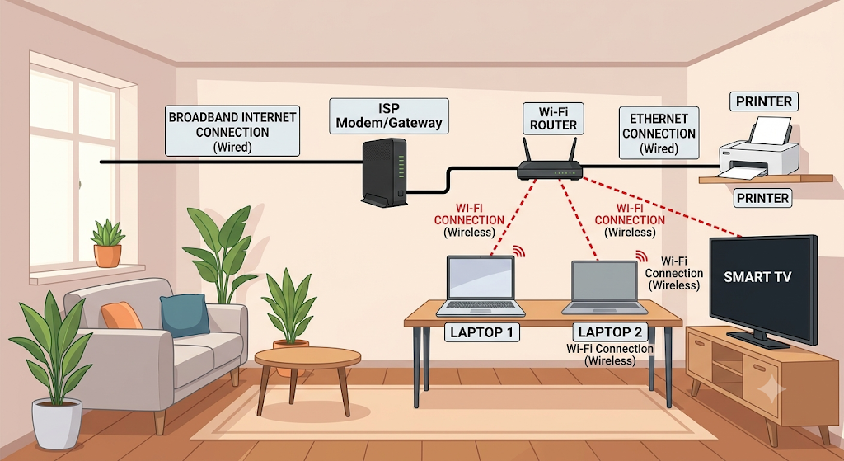

Part 2: Hardware Component List (Indian Market Context) :

- Broadband Internet Connection:
  - Service Provider (ISP): Airtel Xstream Fiber, JioFiber, or local providers like ACT Fibernet.
  - Hardware: Typically, the ISP provides an Optical Network Terminal (ONT) or specialized Modem (e.g., Nokia, Huawei, or Dragon Path brands often supplied by the ISP) that converts the incoming fiber/DSL signal into an Ethernet connection.
- Wi-Fi Router:
  - Suggestion: TP-Link Archer C6 AC1200 Dual Band Gigabit Router. (This is a popular, affordable choice supporting good speeds suitable for most SOHO needs).
- Laptops:
  - Suggestions (Representative): Dell Inspiron 15 or HP Laptop 15s. (Any modern laptop with a functional Wi-Fi adapter).
- Smart TV:
  - Suggestion: Mi TV 5X 50-inch (or Samsung Crystal 4K). These televisions come with built-in Wi-Fi and often an Ethernet port (RJ45).
- Printer:
  - Suggestion: HP LaserJet Pro M126nw (This is a workhorse monochrome laser printer common in India that supports both Ethernet and Wi-Fi connections). For this diagram, we are connecting it via Ethernet (Wired) for high reliability.
- Cables:
  - Requirement: Two CAT6 Ethernet Cables (e.g., brands like AmazonBasics, CableCreation).
    - Cable 1: Connects ISP Modem to Router (typically supplied).
    - Cable 2: Connects Router to the Printer.
- Switches or Extenders:
  - Need: No switches or extenders are necessary for this basic five-device setup, assuming the devices are within normal Wi-Fi range and the TP-Link router has at least four LAN ports (which the Archer C6 does).
Part 3: Step-by-Step Wi-Fi Router Configuration :
Once the hardware is connected (ISP Modem <-> Router), you must configure the router. This setup secures your network and prevents unauthorized access.
- Connect and Access the Router:
  - Ensure your main computer (or Laptop 1) is connected to the router via an Ethernet cable or the router's default, unsecure Wi-Fi (the default SSID/password is usually printed on a sticker on the bottom of the router).
  - Open a web browser.
  - In the address bar, type the router's default IP address. This is typically 192.168.0.1 or 192.168.1.1. (Check the router's documentation or bottom sticker to be sure).
- Log In (And Change the Default Admin Password):
  - A login screen will appear. The default username is often admin and the default password is often admin.
  - Crucial Security Step: Many routers (like modern TP-Link models) will immediately ask you to set up a new, strong administrator password during the first-time setup process. This password is different from your Wi-Fi password; it controls access to these settings. Choose a complex password and write it down securely.
- Find Wireless Settings:
  - Navigate to the Wireless or Wi-Fi settings menu in the router’s configuration interface.
- Set a Unique SSID (Network Name):
  - Find the field labeled Wireless Network Name or SSID.
  - Change this name from the default (like "TP-Link_XXXX") to something unique, such as MySOHO_Office_Net. Using a unique name helps identify your network.
- Enable WPA2 Security:
  - Look for the Security Mode or Authentication Method setting.
  - From the drop-down menu, select WPA2-PSK (AES) or WPA2/WPA3-Personal (if supported). WPA2 is the current strong standard; WPA3 is newer and more secure. Do not use WEP.
- Set the Wi-Fi Password (Pre-Shared Key):
  - In the Password, Pre-Shared Key, or Passphrase field, enter a strong password that you will use to connect your wireless devices (laptops, TV). A strong password is at least 12 characters long and uses uppercase, lowercase, numbers, and symbols (e.g., C0mplex#W!F1%Pass).
- Save and Reboot:
  - Click the Save or Apply button at the bottom of the page.
  - Most routers will prompt you to reboot for the changes to take effect. If not, look for a 'Reboot' option under System Tools. After rebooting, you will need to reconnect your laptops and other wireless devices to the newly named network using the new password.
Part 4: IP Address Configuration Table :
IP addresses identify devices on your local network. We are assigning specific fixed addresses to stationary devices (TV, Printer) for reliability and allowing the router (via DHCP) to handle mobile devices (Laptops).
We are assuming the router's address (Gateway) is 192.168.1.1.
Device | Connection Type | Hardware/MAC Address (Sample) | IP Address | Configuration Method
Wi-Fi Router (Gateway) | N/A | (Printed on Router) | 192.168.1.1 | Static (Default)
Laptop 1 | Wireless | 00:1A:2B:3C:4D:5E | 192.168.1.101 | DHCP (Auto-assigned)
Laptop 2 | Wireless | A0:B1:C2:D3:E4:F5 | 192.168.1.102 | DHCP (Auto-assigned)
Printer | Wired (Ethernet) | 00:11:22:33:44:55 | 192.168.1.20 | Static (Fixed)*
Smart TV | Wireless | 98:76:54:32:10:FE | 192.168.1.25 | Static (Fixed)*
*Important: To set a static IP on the Printer and Smart TV, you would navigate to the network/wireless settings menu on each respective device (not the router), change the IP setting from 'Auto/DHCP' to 'Manual/Static', and enter the listed IP address, Subnet Mask (typically 255.255.255.0), and Gateway IP (192.168.1.1).

Part 5: Troubleshooting Scenario :
Scenario: Laptop 1 (running Windows 10/11) is powered on and configured to use DHCP. It can connect to the Wi-Fi network (MySOHO_Office_Net), but it cannot access the internet. It shows a "No Internet, secured" message.
Here are 3 possible causes and simple steps to fix them:
Possible Cause 1: An Old or Stuck IP Address
The router may have changed settings, or the laptop might be holding onto old network information, causing an IP conflict.
- How to Diagnose: Click the Wi-Fi icon on the taskbar. Check if it says "No Internet" or shows a yellow warning triangle.
- How to Fix: Force the laptop to request a new IP address.
  - Open the Command Prompt (type cmd in the Windows start menu).
  - Type ipconfig /release and press Enter. (This gives up the current IP).
  - Type ipconfig /renew and press Enter. (This requests a new, valid IP from the router).
  - Check if the internet connection is restored.
Possible Cause 2: Physical/Hardware Glitch (Power Cycle Needed)
Sometimes, either the router or the incoming ISP modem just needs a simple restart to clear its internal memory or re-establish its upstream connection with the ISP.
- How to Diagnose: If no devices on your network (including the other laptop or smart TV) can access the internet, this is almost certainly the issue.
- How to Fix: Perform a full power cycle.
  - Unplug the power cables from both the Wi-Fi Router and the ISP Modem (if separate).
  - Wait exactly 30 seconds. (This allows all residual power to drain).
  - Plug only the ISP Modem back in and wait 1-2 minutes for all its lights (especially 'Internet', 'Online', or 'Fiber') to stabilize.
  - Once the modem is ready, plug the Wi-Fi Router back in and wait another minute for it to start up.
  - Reconnect Laptop 1 to the Wi-Fi and test the internet.
Possible Cause 3: Outdated Wireless Adapter Drivers
The software that controls the Wi-Fi card in Laptop 1 might be buggy or corrupted, preventing proper communication with the router.
- How to Diagnose: If other devices on your network can connect to the internet perfectly, the issue is isolated to Laptop 1, and Causes 1 and 2 did not help, outdated drivers are a strong possibility.
- How to Fix: Reinstall the wireless driver.
  - On Laptop 1, right-click the Windows Start button and select Device Manager.
  - Expand the Network adapters section.
  - Find your wireless card (e.g., "Intel Dual Band Wireless-AC XXX" or "Realtek Wi-Fi Adapter").
  - Right-click it and select Uninstall device. (You do not need to check the box to 'attempt to remove the driver software for this device').
  - Restart the laptop immediately. When Windows restarts, it will automatically detect the wireless card and reinstall the drivers fresh from its internal backup. Reconnect to the Wi-Fi and test the internet.

